# **Day 03 Assignment**

/*1. Update the categoryName From “Beverages” to "Drinks" in the categories table.*/

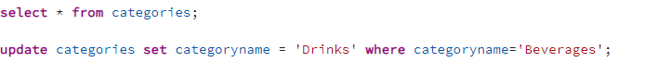

/*2. Insert into shipper new record (give any values) Delete that new record from shippers table.

/* 3. Update categoryID=1 to categoryID=1001. Make sure related products update their categoryID too. Display the both category and products table to show the cascade.

Delete the categoryID= “3” from categories. Verify that the corresponding records are deleted automatically from products.*/

Delete category Id 3

4.   Delete the customer = “VINET”  from customers. Corresponding customers in orders table should be set to null (HINT: Alter the foreign key on orders(customerID) to use ON DELETE SET NULL)

5. Insert the following data to Products using UPSERT:

6)      Write a **MERGE query**:

Create **temp table with name:**  ‘updated_products’ and insert values as below:

**USE NEW Northwind DB:**

7)      List all orders with employee full names. (Inner join)

